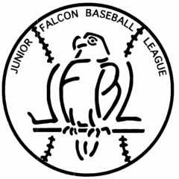

Rules, Registration, and Constitution- www.jfbl.net

Free Online Coaching Manuals/Practice Ideas-
www.alyb.org/_assets/CoachingBaseballforDummies.pdf
www.assets.ngin.com/attachments/document/0042/2781/HowToCoachLittleLeagueBaseball.pdf

Questions/Comments- jrfalconbaseballleague@gmail.com
Junior Falcon Baseball League, PO Box 45 Rushville, Ohio 43150

