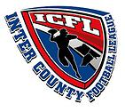
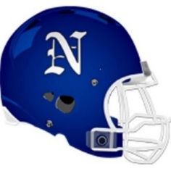
Norristown Youth Eagles, Inc.
203 East Poplar Street
Norristown, PA 19401
Telephone ~ 484.714.7666 ~ Website ~ www.norristownyoutheagles.com

We are pleased to support the Norristown Youth Eagles, Inc. and the youth football and cheerleading program. A financial donation in the amount of $_________ has been included with this form in exchange for the sponsorship option indicated below:

Platinum Sponsor $1000
Business, Organization, or Person will receive a 3x5 sign displayed for 2 years at home field, banner with business logo displayed at snack stand, special recognition throughout season, link to business website on organization homepage.

White Sponsor (Limited Availability) $750
Business, Organization, or Person will receive business logo or name displayed on team jerseys, link to business website on organization homepage.

Gold Sponsor $500
Business, Organization, or Person will receive business logo displayed on banner at snack stand, special recognition throughout season, link to business website on organization homepage.

Silver $250
Business, Organization, or Person acknowledged on webpage and recognition at season opening ceremonies.

Blue - Sponsor a Child $125
Business, Organization, or Person acknowledged at season opening ceremonies.

Other $______

Contact Information
Organization Name/Contact Person: _____________________________________

Address: ___________________________________________________________

City: ________________________ State: __________ Zipcode: _______________

Email: ______________________________Telephone: ( ) ________________

Please make CHECK or MONEY ORDER payable to: Norristown Youth Eagles, Inc. and mail with this form to:
Norristown Youth Eagles, Inc. Attn: Board of Directors, 203 East Poplar Street, Norristown, PA 19401
or call 484-714-7666 for donation drop-off.

*All donations are tax deductible as Norristown Youth Eagles, Inc. is recognized as a 501C(3) organization*

~ Percy L. Jones III, President ~ Roland Marsh, Vice President ~ Hakim K. Jones, Community Relations ~
Matthew Booker, League Rep ~ Melissa Dinnell, Secretary
Jerome Kindell, , Field & Equipment Director ~ Liz Barber, Cheer Director

