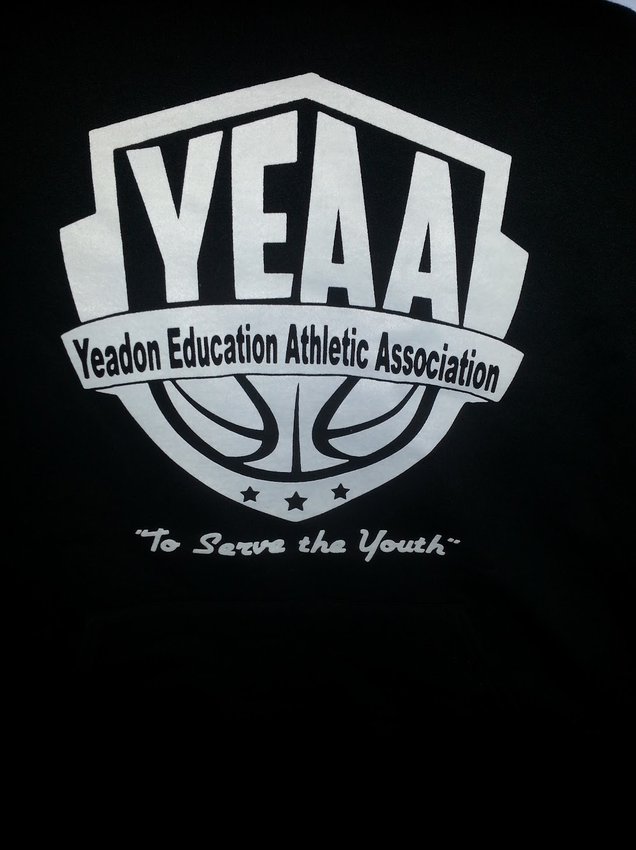

Yeadon Education Athletic Association
To Serve the Youth of our Community

YEAA Players Contract
Code of Conduct

To learn the sport in an environment that is positive, supportive, and healthy; both physically and mentally.

- I Will be a team player
- I Will exhibit good sportsmanship at all times
- I Will work hard to improve my skills
- I Will win without boasting, lose without excuses, and NEVER quit
- I Will treat all players, coaches, and officials with respect
- I Will make every effort to be on time for all practices, games, and other team events and Will notify my coach If I cannot
- I Will do my best to listen and learn from my coaches
- I Will do my very best in school
- I Will talk to my parents and my coaches if I have a problem that I need help with
- I Will not use foul or abusive language
- I Will not use drugs, alcohol, or tobacco
- I Will play for FUN

Athlete Printed Name: _____________________________________________________________

Athlete Signature: __________________________________________________________________

Date Signed: _______________________________

Yeadon Education Athletic Association
To Serve the Youth of the Community

Parental Code of Conduct

To promote the sport in an environment that is positive, supportive, and healthy, both physically and mentally.

- I Will promote good sportsmanship, teamwork, and a competitive spirit for players and spectators in a positive manner
- I Will know and study the rules of the game
- I Will applaud the good plays of both teams
- I Will place the emotional and physical well-being of my child ahead of my desire to win
- I Will support the coaching staff, and resole to allow the coaches to manage the team as they feel best benefits the entire team, with the knowledge that the knowledge that they also have a good code of conduct
- I Will make every effort so that my child Will be on time for all practices, games, and other team events and Will notify the coaching staff if I cannot; and in advance when possible
- I Will Not use profanity or make disparaging remarks or gestures of any type with regard to coaches, officials, or opposing teams
- I Will Not use drugs, alcohol, or tobacco during any YEAA practice, game, or event
- I Will direct any complaints or concerns to the commissioner or YEAA Board Member for action
- I Will remember that they play for FUN

Parent/Guardian Printed Name: ___________________________________________________________

Parent/Guardian Signature: ________________________________________________________________

Date Signed: __________________

