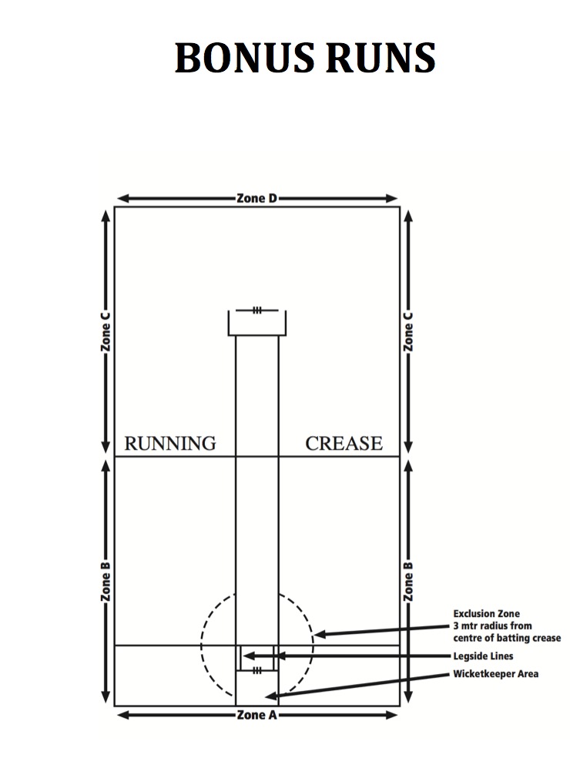

ZONE A (REAR WALL) | 6 RUNS ON FULL, 4 ON BOUNCE
ZONE B (NEAR SIDE WALLS) | 3 RUNS
ZONE C (FAR SIDE WALLS) | 2 RUNS
ZONE D (FAR WALL) | 1 RUNS
SIDE WALL ONTO REAR OR FAR WALL | 3 RUNS

